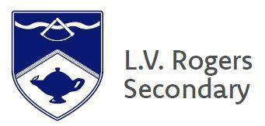
2024-25
BC GRADUATION PROGRAM (Gr. 10-12)
2017-17

LVR COURSE & PROGRAM
OPTIONS

SET UP FOR SUCCESS

ASK GREAT QUESTIONS!

PARENTS/GUARDIANS/STUDENTS—
YOU ARE INVITED TO ATTEND THESE SESSIONS in the LVR GYM

Monday, February 12th : 6:30 pm
Current Gr. 9 Families (Next Year’s Gr. 10’s)
LV ROGERS SECONDARY
1004 Cottonwood St Nelson BC

ph: 1.250.352.5538
http:/lvr.sd8.bc.ca/

Tuesday, February 13th : 6:30 pm
Current Gr. 10 & 11 Families
(Next Year’s Gr. 11’s & 12’s)

