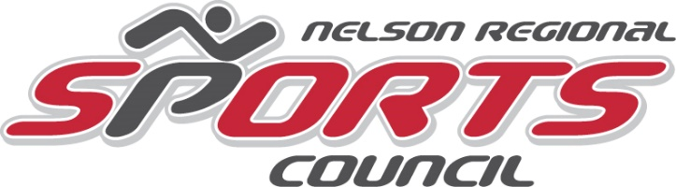
9.4 Scholarships Submission to: SD8 DEADLINE APRIL 17
Send Applications directly to nelsonsportscouncil@gmail.com
Policy
The purpose of this policy is to support a student to participate in post-secondary education.
- One Scholarship shall be awarded per year.
- Current Board or staff members and their families are ineligible to apply.
- The scholarship recipient shall be selected from candidates that demonstrate the following attributes:
  - A candidate who has shown worthwhile contributions to a provincial or national association in sport as an athlete, and/or official, or club/district administrator.
  - The candidate must have demonstrated good citizenship, character and leadership.
  - Students proceeding from Grade 12 to university or other secondary institution approved by the NRSC Scholarship selection committee.
- The Scholarship Selection Committee shall not enter into correspondence with the candidate, their family or agent.
- The decision of the committee is final.

Procedures
- Candidates must complete the NRSC Scholarship application form in its entirety to be considered. All parts must be complete.
- Candidates submit the application to their high school within the relevant school policies and deadlines, or if Homeschooled, submit directly to the NRSC. (Address above.)
- School staff shall forward all application from their school and submit these to the NRSC by April 30.
- It is the candidate's responsibility to ensure that the application is complete and that all required information and documentation is enclosed with the application.
- NRSC committee shall accept all submission from each local high school in the region and select one recipitent per year from either: LVR, Mount Sentinel, Salmo Secondary, JV Humphries (or a Homeschooled student).
- The NRSC selection committee shall decide after a panel interview of the four finalist are completed and select the best recipient or recipients from the submissions.
- The NRSC committee decision and announcement shall be made to the recipient school counsellor sponsor
- and School District 8 by May 30.
- The Scholarship shall be awarded at the graduation ceremony, or in the case of a Homeschooled student, mailed directly to the students by SD8 to their home upon proof of post-secondary attendance (see below).

9. Condition:
  - The funds shall be distributed by the Osprey Foundation to the School District #8 who will in turn issue to the student upon proof that he/she is attending a post-secondary institution as approved by the selection committee.

NRSC Scholarship Application Form
Send Applications directly to nelsonsportscouncil@gmail.com
Deadline: April 17th
BEFORE COMPLETING THIS APPLICATION, PLEASE READ THE ATTACHED POLICY.
APPLICANT’S NAME | DATE OF BIRTH (D/m/YYYY)  GRADE COMPLETING
HOME ADDRESS  Postal code | EMAIL ADDRESS
PHONE # | ALTERNATE PHONE #
NAME OF HIGH SCHOOL | PHONE # OF HIGH SCHOOL
COUNSELLORS NAME/School sponsor

HIGH SCHOOL ADDRESS | HIGH SCHOOL EMAIL ADDRESS
PLEASE LIST THE COURSES YOU ARE COMPLETING THIS SCHOOL YEAR | PLEASE LIST THE COURSES YOU COMPLETED LAST SCHOOL YEAR
PLEASE LIST ANY HONOURS OR REWARDS YOU HAVE RECIVED DURING THE LAST THREE (3) YEARS (Scholarships, Citizen, Fine arts, Service, Sports etc.)

What are your vocation goals?

Which educational institute (or the like) do you plan to attend next year?

Applicant’s signature______________________________________________________________

Date of application_______________________________________________________________

